February 3, 2023

Rulemakingcomments@dep.nj.gov

RE: Comments on DEP Rulemaking
Inland Flood Protection Rule
DOCKET No. 11-10-11

Dear Sir or Madam:

The New Jersey Association for Floodplain Management (NJAFM) supports state efforts to proactively address worsening riverine flooding and stormwater runoff anticipated from a warmer and wetter climate in New Jersey. NJAFM members include a wide array of floodplain and community resilience professionals such as floodplain managers, engineers, planners, construction and code officials, grant writers, engineers, municipal zoning officials, and municipal business administrators. Our organization is dedicated to reducing the loss of life and property damage resulting from floods and promoting sound floodplain management in New Jersey. Many of our members have earned national Certified Floodplain Manager (CFM) designation which tests competency with FEMA National Flood Insurance Program (NFIP) regulations and the technical aspects of floodplain management including interpreting flood mapping, setting design flood elevations, and evaluating flood mitigation construction practices.

As an organization with a demonstrated commitment to improving floodplain management practices in our state, NJAFM applauds the State’s use of science and research to help determine future flood conditions. Our organization welcomes this opportunity to provide comments on the proposed Inland Flood Protection rules that we believe will help provide a more accurate assessment of future flood risk facing New Jersey communities. Because of this, it is suggested the state take additional time to evaluate the suggestions contained herein before implementing proposed changes to the current rules.

- In Regards to 7:8-5.4(b)1.i - The proposed regulations do not update the groundwater recharge spreadsheet which most proposed site development recharge designs are based upon. Within the following section, 7:8-5.4(b)1.ii, the regulations allow as an option the projected difference in volume between two year storm events. The two sections of the regulations are inconsistent as one section permits the use of a lesser recharge standard; whereas the following section implements the year 2100 standard. It is recommended to maintain the recharge requirement for 7:8-5.4(b)1.ii to be only the current design storm volume difference, and ignore projected rainfalls.

- In Regards to 7:8-5.7 - The Curve Number method was originally created in the 1950s for only Agricultural Watersheds based on only annual rainfall events. To many of the authorities in this country on the Curve Number method, it is not considered a science but an administrative tool. In many situations, it does not consistently predict the rainfall/runoff process.

  - There is no need to remove the Rational Method nor the Modified Rational Method, particularly for small areas. The Rational Method and the MRM are quite applicable in small drainage areas and storm sewer system designs for residential development. The USDA NRCS Curve Numbers (and the Rational C values) are not atomic weights. For example, in USDA NRCS NEH4, a Curve Number of 70 for “Row Crops Contoured” is the median Curve Number. This value has a confidence limit between ARC I 66 to ARC III 74. Any of these values can be used for “Contoured Row Crops”. The same applies to urban conditions.

  - The NJWQDS will need to be reevaluated if the Rational Method is removed. Currently, the NJWQDS is 1.25 inches of rain over 2 hours. The NRCS Curve Number method only uses 24 hour storms.

  - The USDA NRCS Curve Number is dependent on the amount of rainfall. Determination of the CN number follows an asymptotic approach as seen in the below graph.
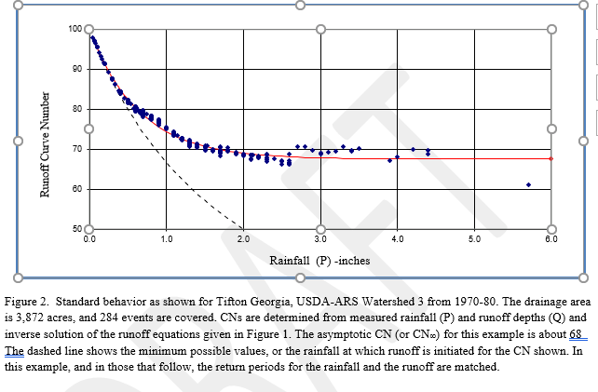

The distribution of CN values along the asymptotic line is log Normal. This scenario fits the Piedmont area of NJ.

The following graph shows the plot of complacent Curve Numbers typical in South Jersey Forested watersheds. Under this condition a Curve Number cannot be determined.
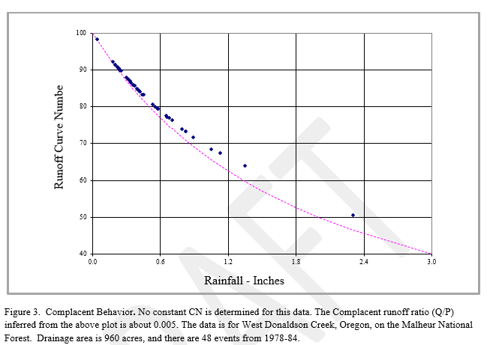
  - The USDA NRCS Curve Number was based on annual rainfall events only using daily volumes. Research conducted by Richard Hawkins and later by Bondelid found there was more of a correlation between rainfall/runoff than CN to runoff. This was particularly true for small rainfall amounts and rainfall amounts near the initial abstraction thresholds.

- In regards to the statement “Issues exist with each of these variables that severely limit the utility of these methods for purposes of computing the rate of runoff generated on a site” - Both the Rational Method and USDA NRCS Curve Number method have similar issues.
  - The USDA NRCS Curve Number method, in general, is not applicable for Forest Conditions. The Land Use Category of Woods in USDA NRCS NEH4 is not Forest. The Woods in USDA NRCS NEH4 are Farm Stands lots urban parks.

  - The Rational method and to a certain extent the USDA NRCS Curve Number method assumes there is an overland flow condition. The existing condition in Forested areas with HSG A (and B) soils is a subsurface condition. How will proposed development match subsurface flow conditions? Using what model? When using the Rational or Curve Number method, in the post developed condition, overland flow suddenly appears after a rainstorm event when it never did before and sometimes result in flooding that also never existed before.

  - Many submitted pre-developed hydrology calculations that are received by municipal and SCDs in Central and South Jersey have calculated peak flows that historically have never existed. This is primarily due to the mandated misuse of USDA NRCS CN method and the fact the certain areas of NJ have existing subsurface flows.

  - NJDEP mandates the use of the “McCuen-Spiess” regarding sheet flow. However, NJDEP needs to also refer to USDA NRCS Technical Note N4 “assumption is that rainfall excess intensity equals rainfall excess.” A 2-year storm event in Forested HSG A/B Conditions does not necessarily give you an overland flow condition. Implementation of USDA NRCS segmental method cannot be done without adhering to USDA NRCS N4 The NRCS procedure for estimating the time of concentration in a watershed (the segmental method) is presented in NRCS’s Hydrological technical Note No. N4, Welle and Woodward (1986). This technical note species that a 2year overland flow must exists in order to implement the segmental method or for any other constraint

  - There are stated limitations to the USDA NRCS Curve Number method in TR 55. Should these limitations be encountered, the following statement is “use another procedure.” If there are no other procedures, then how will these limitations be addressed if only USDA NRCS Curve Number method is specified?

  - The NJDEP should address other hydrology models other than the USDA NRCS Curve Number method. There is research and documentation that shows the Curve Number method is not applicable in parts of New Jersey. Such research has been submitted to NJDEP by Dr. Richard Hawkins (former co-chair) of the ASCE Curve Number Hydrology Group in his study of McDonald’s Branch, which shows that the Curve Number is not applicable in the Pinelands National Forest Preserve. We recommend investigation into using Wildcat5 or the Green-Ampt models. The Green-Ampt can be run by using HEC-HMS. These two models can handle the porous soils forest conditions of South Jersey, which the standard Curve Number method cannot.

  - The minimum time of concentration according to the NRCS Curve Number method is 0.1 hours (6 minutes) but the proposed rules removed the minimum time of concentration constraint.

- In Regards to 7:8-5.7(c)1&2 - The stormwater regulations require the use of the NOAA storm rainfall total estimates for the various storm events with a reference to the NOAA website. The regulation at a minimum should include the published date of these rainfall tables such that a NOAA change adjustment will not adjust the stormwater design standards within New Jersey. Table 5-5 Current Precipitation Adjustment Factors should be amended to include the current NOAA rainfall rates for the 2, 10 and 100 year storms and should specify the year current rainfall rate to be utilized for design. The NOAA rainfall rates are not specified in the proposed regulation.

- In Regards to 7:8-5.7(d)1&2 - The stormwater regulations require the use of the NOAA storm rainfall total estimates for the various storm events with a reference to the NOAA website. The regulation at a minimum should include the published date of these rainfall tables such that a NOAA change adjustment will not adjust the stormwater design standards within New Jersey. Table 5-6 Future Precipitation Adjustment Factors should be amended to include the current NOAA rainfall rates for the 2, 10 and 100 year storms and should specify the year current rainfall rate to be utilized for design. The regulation is complex in that the regulation indicates to multiply the ambiguous and indirectly referenced NOAA rainfall rates by Table 5-5 and then by Table 5-6.

- In Regards to 7:13-1.2 - The creation of a definition of a public transportation entity provides the State of New Jersey with a mechanism for not following the potentially adopted flood hazard regulations. Public entities should be required to follow and implement the same flood hazard standard as those enforced onto private entities and other types of public development. Public entities should be required to meet the proposed flood hazard standards without exception.

- In Regards to 7:13-3.3 - The blanket addition of 2 feet to the previously adopted state flood hazard studies is arbitrary. The permitted reliance on these outdated studies should be eliminated from the flood hazard regulations for proposed design. The State of New Jersey utilizing the current best available technology and data through engineering and scientific study should provide continuous funding such to update to these long outdated maps. The regulations should be revised such that if the applicant chooses not to utilize these prior studies, the applicant has the ability to update portions of these maps with the newly adopted procedures, without penalty. Adding 2 feet of freeboard to these previously outdated mapping products with either significantly over-estimate the location of the flood hazard area and/or will result in a significant under-estimate of the actual flood hazard area. Although the base mapping data is not current to the existing conditions of the state, the flood studies at a minimum should be updated to account for the additional flood flow rates and updates to those maps should be published for public comment, review; with notice provided to the directly impacted property owners.

- In Regards to 7:13-3.4(e)1 - The arbitrary addition of 3 feet to a FEMA flood map product is inappropriate. Some FEMA flood maps include the NJ Flood Hazard Design Elevation, such that to be consistent with 7:13-3.3, maps that provide a NJ Flood Elevation should be identified as 2 feet. Furthermore, the additional freeboard within broad flood hazard areas does not account for storage volume attenuated in the flood fringe.

- In Regards to 7:13-3.6(c)1i(2) - The implementing statutes discuss the 100-year design storm without the addition of 125% factors. The use of 125% is an additional safety factor that should be eliminated if rainfall events are based upon the 2100 predicated flow rates. There is also a need to eliminate the 125% design factor as new development is required to provide peak flow reductions. The current permitted practice is not to allow and/or consider existing and future stormwater management features. Ignoring existing and proposed stormwater features in the flood modeling is an oversight. The SCD has a database of existing and proposed stormwater management facilities with proposed flow characteristics. The statutes also do not address future design storms. A change in the state law to implement the proposed changes in the flood hazard regulations should be discussed. Although the NJDEP may choose to map the project flood hazard areas, these areas should be regulated similarly to a 500-year flood hazard elevation. Regulations should allow fill with the area between the current 100-year storm and the projected 100-year storm, without penalty to the property owner. Building finished flood elevations can be located above the 500-year flood level.

- In Regards to 7:13-3.6(c)iii.1 - The proposed flood hazard regulation is inconsistent in regards to the calculation of the floodway. If NJDEP is going to adopt a flood hazard regulations for the future design storm, then the floodway should also be computed based upon those future rainfall events.

- In Regards to 7:13-3.6(c)iii.5 – Table 3.6A should be revised to reflect the exact rainfall rate to be utilized within the calculations, such that there is no indication within the regulations on how to multiply the values considering significant figures. Modeling software may truncate rainfall rates to the hundredth. The regulations should specify if the rainfall rates are rounded to the nearest one tenth, one hundredth. The NOAA rainfall tables should be published as part of the regulation such that the source is adopted with these regulations such that there is no ambiguity.

- In Regards to 7:13-3.6(c)iii.6 - Table 3.6b should be revised to reflect the exact rainfall rate to be utilized within the calculations. The NOAA rainfall tables should be published as part of the regulation such that the source is adopted with these regulations such that there is no ambiguity.

- In Regards to 7:13-12.6(b)2 - There should be no separate carve out for public roadways or entities. Non-compliance for existing infrastructure improvements should be administered as a hardship exemption such that public notice is provided to indicate the non-compliance.

NJAFM appreciates the opportunity to comment and we look forward to working with the State and the DEP towards proactive floodplain management throughout New Jersey.

Sincerely,

Elissa Commins, Chair
NJAFM

Bryan Specht, Stormwater Committee Chair
NJAFM

